MACROECONOMICS - II

**IMPACT OF RUSSIAN AND UKRAINE WAR ON INDIAN ECONOMY**

ARYAN GUPTA

20HS20011

horizontal line

# 

# Introduction

The Russian invasion of Ukraine in February was the biggest conventional military operation since World War II, and it has the potential to devastate the global economy. Its impact is showing everywhere and no one will remain unaffected.Many countries have strongly condemned Russia for this invasion and have put many economic sanctions on Russia leading to the fall of the value of the Russian currency ‘Ruble’.

India has adopted a neutral stance as a result of its long-standing strategic alliance with Russia. This Cold War-era cooperation encompasses numerous fronts—diplomacy, defense, nuclear energy, and technology—making Russia an important element of India's nation-building process, particularly during its infancy.

However, this is unlikely to protect India from the horrors of a conflict of this magnitude. Especially when, in the global geopolitical framework, both India and Russia are increasingly intertwined with two other nations, China and the United States.

The current Russia-Ukraine conflict may have influence on some high-frequency indicators such as financial markets, currency rates, and oil prices, according to a paper by analysts at the State Bank of India (SBI). It was highlighted, however, that this event will not have long-term influence on the Indian economy.

## Effects of War on India

The Russia-Ukraine crisis has increased global trade uncertainty and will have an impact on oil and other commodities. Despite the fact that India does not have a major merchandise trade with Russia, it stands to lose economically as a result of supply interruptions created by Western sanctions.

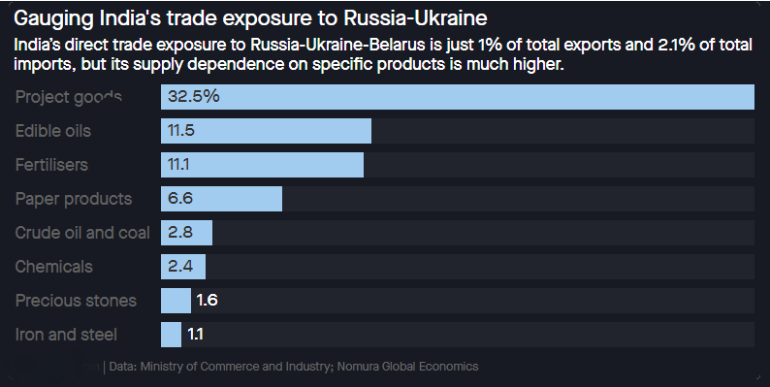

Here are some of the ways India may suffer as a result of a Russia-Ukraine war without even part of it.

### Economic Growth

Ratings agency Moody’s Investors Service has reduced its growth prediction for India for 2022 by 0.4 percentage point. Moody's predicted that the Indian economy would grow by 9.1% this year (up from 9.5% previously), followed by 5.4 % growth in 2023.

JP Morgan also downgraded India to 'underweight' from 'neutral' saying GDP growth may underperform, adding to the downside risks to EPS expectations.

While SBI reports expects negligible impact of Russian and Ukraine conflict on the Indian Economy and expects Indian economy to enter a high growth rate of 9.2 percent in FY22(over 6.6% in FY21).

### Crude Oil Price

In response to the United States' embargo on all Russian oil and gas imports, Brent crude prices jumped to almost $130 per barrel in mid March 2022, up 43 percent from the beginning of February.

This is a big setback for global economic growth because Russia is one of the world's leading crude oil suppliers. However, India's commerce only accounts for 1% of Russian oil imports, but there may be a spillover effect in the shape of high prices and slow growth.

Since India is a heavy oil importing country with 85% of its oil consumption being imported, a rise in oil price will have a heavy impact on India’s economy.

Morgan Stanley cut India's GDP prediction for fiscal year 2023 by 50 basis points to 7.9 percent on March 13, citing concerns of macro stability caused by rising crude oil prices.

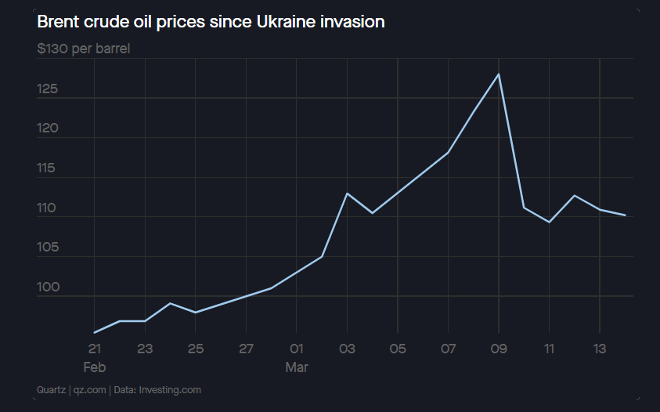

It is estimated that if global economic circumstances deteriorate more, India's export and capital spending cycles will suffer.

### Grain Market

The Ukrainian conflict has given an odd opportunity for certain Indian agri-exporters dealing in wheat, maize, millet, and processed food. Since the crisis erupted last month, the globe has been looking to Indian wheat to fill the massive hole in inventories left by the turmoil in Europe's breadbasket. Ukraine is one of the world's leading wheat exporters, with Russia and Ukraine accounting for 25% of the worldwide wheat market.In the case of maize, Ukraine accounts for 13% of world commerce, with half of its exports destined for the lucrative European Union market.

According to an analysis by the Agricultural and Processed Food Products Export Development Authority (APEDA), an agency under the Union Ministry of Commerce and Industry, a ban on Russian flights to Europe means opportunities for Indian exporters of processed food — nuts, fruit juices, confectionary, pulse and cereal preparations, among others.

Since Russia's invasion of Ukraine, global wheat prices have reached all-time highs. Following the outbreak of war in eastern Europe, the worldwide Chicago benchmark for wheat increased by 50%, with global prices reaching about $14 per bushel (roughly 30kg).The wheat price is fourteen year high.

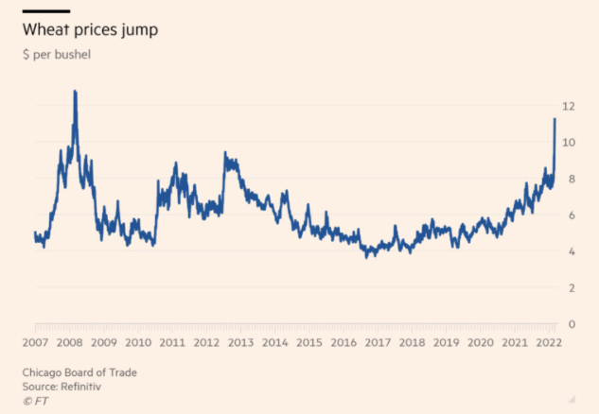

The whole globe is relying on India for wheat supplies, and the commodity's price on the international market has risen, allowing exporters and farmers to earn quick cash.

The Indian wheat market has increased its distribution to the global market and is looking forward to capture the global share in the wheat production.

### Inflation

Russia has accounted for 2.8% of our total imports thus far in FY22.India has a trade deficit with Russia, with exports falling and imports rising. Oil is a big component of our Russian import basket.With 85 percent of India's crude oil demands being met by imports , the peak in oil price will now result in broader price pressures.

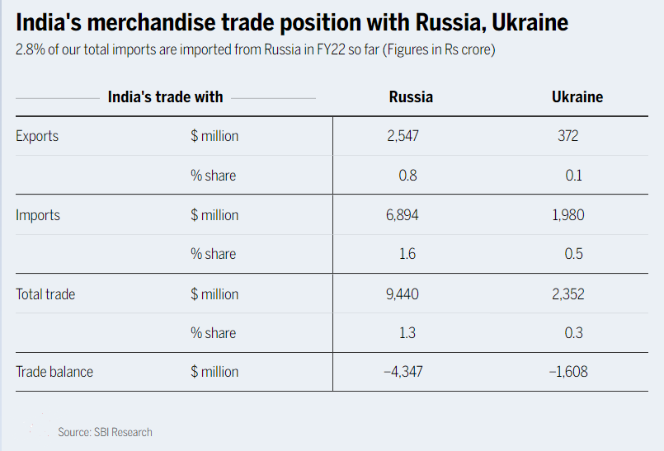

According to analysts, the impact on India's economy would be seen mostly through increasing cost-push inflation, which will affect all economic agents—households, enterprises, and the government.According to Nomura, every 10% increase in crude oil prices translates to a 0.4 percentage point increase in consumer inflation.Morgan Stanley forecasts retail inflation at 6% for fiscal year 2023, far higher than the RBI's 4.5 percent.

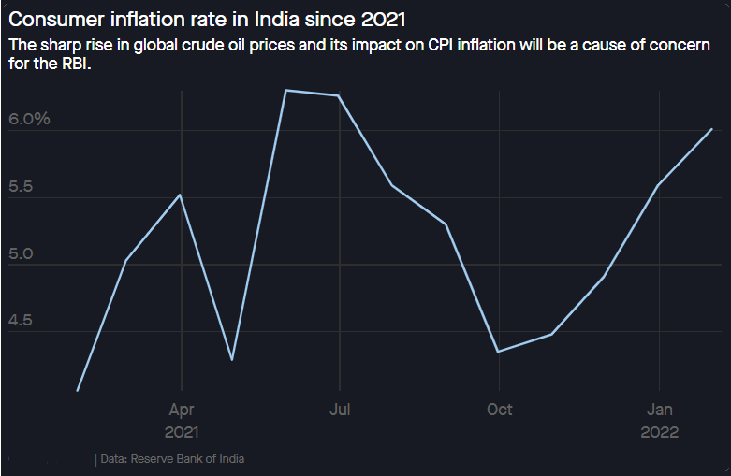

This has raised the likelihood of a greater import bill and, as a result, an expansion of India's current account deficit (CAD). According to Nomura Research research, the CAD is likely to increase to 2.6 percent of GDP in fiscal year 2023, up from 1.7 percent last year.

### Currency

The Indian rupee has suffered as a result of the global economic uncertainty induced by the Russia-Ukraine conflict. The Indian rupee debuted at a record low of 76.93 per US dollar(on6 th March 2022).

The rupee has fallen 3.5 percent versus the US dollar in 2022, with the main reasons being Oil prices shock, rise in US dollar index and relentless foreign portfolio investment (FPI) outflow in the equity market.

The RBI's vigorous involvement, on the other hand, has kept volatility to a minimum. The rupee is likely to continue under pressure until oil prices decline. Volatility, on the other hand, will be quite high. Over the short term, a range between 76.50 and 78.50 might be expected.

Following an uptick in geopolitical tensions during the last 10-12 trading days, the central bank has intervened rather actively in the currency market. The vigorous intervention has reduced the rate of rupee depreciation. Nonetheless, the Indian rupee is the poorest performing currency in Asia in 2022.

The rating agency ICRA expects the US dollar-INR cross rate to trade in a range of 76.0-79.0/$ until the conflict subsides.Furthermore, given the imminent rise in supply, the 10-year G-sec yield is expected to range between 7.0 and 7.4 percent in H1 FY2023.

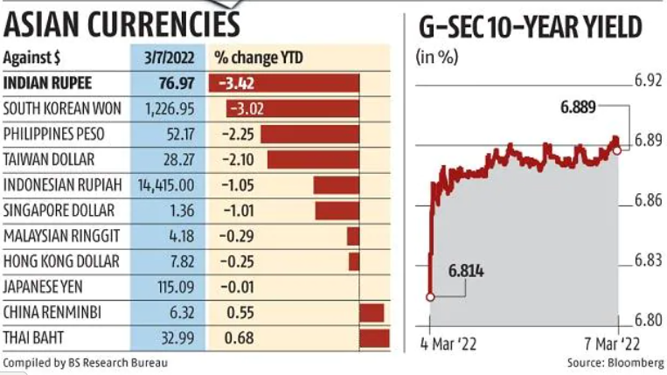

**Conclusion**

The Russia and Ukraine conflict has stunned the whole world economy. India's economy is also not remain unaffected.But many researchers concluded that its impact will not remain permanent on Indian economy and is only temporarily.This event provides Indian grain market opportunity to capture global market and government is also taking all the steps for this.One of the main impact of this catastrophe is rise of oil price all across the world as various western sanctions has stopped countries to trade with Russia oil markets which are the largest provider of crude oil.The country like India whose about 85% of oil consumption is imported will be affected by it most as this will contribute in inflation etc .

**Reference**

* <https://economictimes.indiatimes.com/news/economy/foreign-trade/russia-ukraine-war-impact-indias-grain-exporters-are-gearing-up-to-fill-the-huge-gaps-in-global-stocks-especially-wheat/articleshow/90464830.cms>
* <https://economictimes.indiatimes.com/news/economy/indicators/russia-ukraine-war-prompts-downgrade-in-eco-growth-forecasts/articleshow/90283012.cms?from=mdr>
* <https://www.business-standard.com/article/economy-policy/fallout-of-russia-ukraine-war-rupee-nears-77-in-all-time-low-122030701582_1.html>
* <https://timesofindia.indiatimes.com/business/india-business/explained-how-russia-ukraine-conflict-may-impact-indias-economy/articleshow/89909200.cms>
* <https://farmpolicynews.illinois.edu/2022/03/wheat-soars-to-14-year-high-surge-to-14-possible-citigroup-says/>